Name: Vik Thor

age:

gender: male

personality: Nice, light hearted. Likes to charge into a fight while being outnumbered. Secretly competitive but tries to deny/hide it. Handy man

appearance: Wears a big suit of armor. Carries large weapons, like rocket launcher, huge swords/hammer/lance

backstory: Co-founder of Oysha. After Asta left he tries to retire often wondering around until team Oysha call him back for duty

rank: low Adamantite

strength: Aoe attacks. Annihilating groups of enemies at a time

interaction with main character: when the main character got into trouble, Vik Thor swoops in to help him out.

likes: steak

dislikes: vegetables

habits: charging in when he sees a group of enemies

goals: relax

character inspiration:

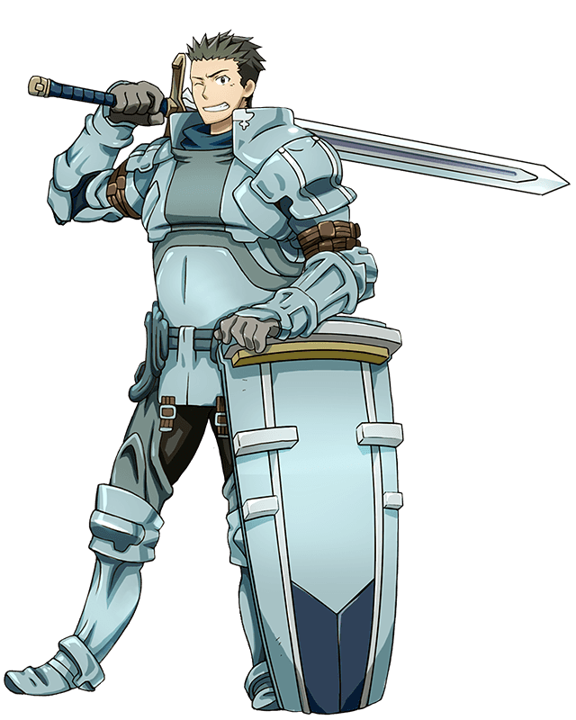my friend victor and small parts of my personality